

**Module Title Information Systems Analysis**

**Assignment Title Infinity Games**

**Examination Cycle Spring 2024**

**Candidate Name THI HAN NAING**

**P00189889**

**Candidate No**

**Centre Name KMD Computer Centre (Yangon)**

**Submission Date: 15-Jan-2024**

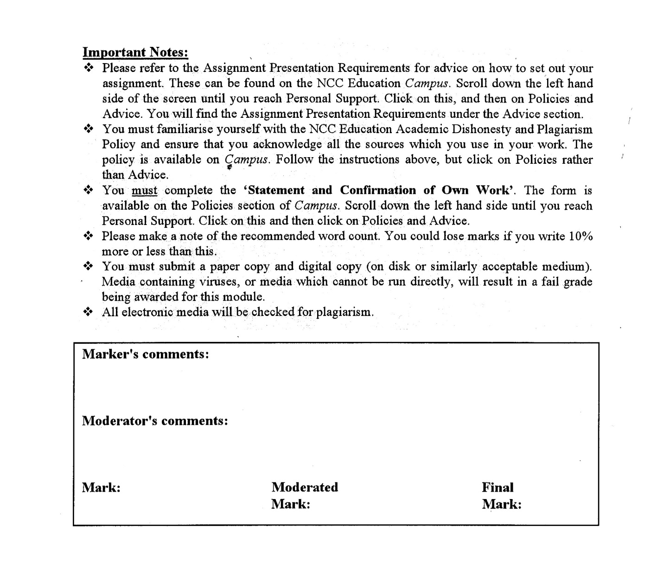



**Statement and Confirmation of Own Work**

**Programmed/Qualification name: Level 5 Diploma in Computing**

*All NCC Education assessed assignments submitted by students must have this statement as the cover page or it will not be accepted for marking. Please ensure that this statement is either firmly attached to the cover of the assignment or electronically inserted into the front of the assignment.*

**Student declaration**

I have read and understood NCC Education’s Policy on Academic Dishonesty and Plagiarism.

I can confirm the following details:

**Student ID/Registration number : P00189889**

**Name : THI HAN NAING**

**Centre Name : KMD Computer Centre (Yangon)**

**Module Name : Information Systems Analysis**

**Module Leader : AYE AYE KYAW**

**Number of words : 1280 Words**

I confirm that this is my own work and that I have not plagiarized any part of it. I have also noted the assessment criteria and pass mark for assignments.

**Due Date : 15-Jan-2024**

**Student Signature : THIHANNAING**

**& Submitted Date** **: 15-Jan-2024**

Table of Contents

Introduction 4

Task 1: Information Systems Analysis 6

Task 2(a): Approache to System Analysis 10

Task 2(b) Design a Rich Picture…………………………………………………………… 12

Task 3: CATWOE Analysis 13

Task 4: Process Oriented IS Methodology 18

Task 5: PEST Analysis 20

Task 6: User Interface Design ……………………………………………………………… 22

Task 7: Evaluation ……………………………………………………………………………25

References 27

Candidate Checklist 29

# Introduction

This assignment is about which the systems that should be using in Infinity Games (a game developer company) to improve their company’s growth. In Task 1, creating Information System Analysis for company is included. In task 2, which type of Approaches should be using for company’s information system. In task 3, CATWOE is explained and applied to the company’s system. In task 4, Process Oriented IS Methodology is explained and is used in player support’s ticket managing system and evaluated the use of process oriented against people oriented. In task 5, PEST Analysis is applied to the company and explained how each factor effect the company’s downfall and. In task 6, dashboard User Interface Design for project manager is developed with the main key features requested. Task 7 is about evaluating all the effectiveness of the tools used and suggesting the tools/methodologies that should be using for the company.

**Task 1**

**Information System Analysis**

# Task 1: Information System Analysis

**Advantages and Disadvantages of each methodology**

|  |  |  |
| --- | --- | --- |
| **Methodologies** | **Advantages** | **Disadvantages** |
| Waterfall | -Milestones and deadlines are defined clearly  -Data information and requirements are already determined from the beginning of the process  -Costs can predictable  -Has clear structure than other methodologies  (Paredes, n.d.) | -Difficult to make changes during project or even after launching  -Not suitable for large size projects  -Deadlines problems may occur  -the process cannot go forward until one phase is finished  -previous phases error occurrences is needed to solve first and can delay the project  (Hoffman, n.d.) |
| Agile | -Error handlings are faster  -Flexible and reduced risks  -Better customer services  -Team members, stakeholders and customers can share information, responsibilities and increase their skills  (Singh, n.d.) | -Not suitable for all type of projects  -Focusing one goal is not easy since it will have more separate goals  -Documentation is always a problem  -Cost predictions cannot be done  -Has no finite end nature (Singh, n.d.) |
| Prototyping | -Reduce time and costs  -Can fix issues in early stages  -Early feedback from end users  -Flexible and testing can be done in early stages  (Rana, n.d.) | -Expensive  -Cannot be used for large projects  -can make hard times for designers, UI UX developers and reduce their enthusiasm  -limitations and constraints are always increase  -requirements are varies and never complete  (Rana, n.d.) |
| User-Centered Design | -Good feedbacks from users and customers  -Improve user experiences  -Increase sales, high accessibilities  -Cost for redesigning is reduced  (Anon., n.d.) | -A lot of researches are needed  -Time limitation is a problem  -Cost for researches and testing are expensive  -Relying on customer feedbacks can lead to lack of innovations  (Anon., n.d.) |

**The information gathering process of each methodology**

|  |  |
| --- | --- |
| **Methodology** | **Information gathering process** |
| Waterfall | Waterfall methodology gather information at the beginning since it is a linear project. For example, the game designers, the stakeholders, the developers, the project managers and graphic designers work together to make the researches and determine the goals for each pool. (Anon., n.d.) |
| Agile | In Agile methodology, requirements are managed in short cycles called sprints and the team will find and gather information at the beginning of each sprint. Since it’s iterative nature, there will be quite numbers of sprints. For example, the game designers, the project managers, the developers work in collaboration and gather information, the director and the stakeholders can negotiate about the project requirements and the user feedbacks from player specialist is added to the information gathering stages of each sprint. (Anon., n.d.) |
| Prototyping | In Prototyping methodology, the team gather required information and make a prototype based on that information. Depend on that prototype, the new information are gathered again. Then rework the prototype and tested again until the necessaries of the prototype is accepted and achieved. For example, the team gather information and game designer and graphic artists will develop a prototype. The project manager and the director will show the prototype to stakeholders and customer. If the project is not satisfied, the team will gather information again and remake the prototype till it’s satisfied. (Anon., n.d.) |
| User-Centered  Design | User-Centered Design methodology is also iterative and the team gather information by understanding the users likes, trending designs, functions and technologies. For example, the team gather the information depending on the factors mentioned above, and evaluated. If it’s not satisfied and not good for user experience, it is designed again. (Anon., n.d.) |

**Conclusions**

Based on the findings, agile methodology should be used for Infinity Games, since the game developments are never ending, the designing creativities, and the customers feedbacks are needed. And the processes must be fast and always innovative to give the customers the best experiences.

**Task 2**

**Approaches to System Analysis**

# Task 2 : Approaches to System Analysis

1. **Human Resource Management**

|  |  |
| --- | --- |
| Soft Approach | -Soft approach focus on employee’s requirements, emotions and their creativities. This helps solving the conflicts within the company with the lesser damage. It also works helping out the employees’ worries and deadline problems or education problems or the needs and requirements of the employees in the way of diplomatic and gentle solutions.  -For example, during the conflicts, the director (Alex Scott) or project manager will focus on problem genteelly or diplomatically. Since the project manager will be using soft HRM, he understands the perspectives of all departments and parties including stakeholders, sale and marketing, design teams, developer teams and will show empathy, active listening during conflict solving. He can make a five-minute meeting every day where employees can present the status of the works or the confess the problems they facing. This type of meeting will help PM or director know more about the job progress and problems that happening in the company. And since they also involves with the jobs, they knows about the problems that employees facing and able to solve that with better solutions and correct decisions. (Anon., n.d.) |
| Hard Approach | -Hard approach focus on company’s productivity using strict or forceful methods on employees. This method can acquire many objectives within a short time generally but conflicts inside the company will get higher especially for the companies which need creativities and teamwork.  - For example, director or project manager in this approach be like authoritative style, strict and the view the employees as valuable resources and this also goes the same for the stakeholders. Solution in this system may include hard way like firing, punishments, penalties. In this system leaders, director or PM can make rewards and punishments system which mean the employees can able to get rewards if they work hard and at the same time they will get punished if they late or failed. This type of system is included in hard HRM and this technique can boost the productivity. Although hard approach may be productive and discipline, problem solving may lead to tensions which can cause negative side effects between departments and project manager, leaders or director. (Anon., n.d.) |
| Combined Approach | Combined approach is the method of combining these two approaches(soft approach and hard approach). In this case, the leaders, project manager or leader may be using soft approach to solve the conflicts between the employees and hard approach for the project productivity.  -For example, project manager may be using hard approach for productivity related jobs like asset management, marketing teams and sale representative team. And he/ she may also use hard approach when facing deadlines problems or projects that need to rush. These types of department will not need much innovations and are likely stereotypes hard HRM will be used here. But if the conflicts or problems may occur soft approach can be used. Development teams, designing team or customer servicing team will need lots of innovations and creativities. For these departments, PM may use soft HRM for them increase their creations. But if they get too lazy or showing undisciplined behavior because of soft HRM, hard HRM could be used again to avoid these problems. So as a conclusion, project manager will be using suitable approach for the different teams and will be using appropriate method of solutions for different types of conflicts and social or personal problems that employees facing within a company. (Anon., n.d.) |

In this case, the soft approach would be suitable since the company will need lots of creativities and departments are working as a team. Using soft HRM would increase the creativities and innovations which will make company’s reputations get higher and can able to make larger and better more projects. Assuming that having lot of jobs will make employees less free time can fill the hole of soft HRM which is having lazy employees or undisciplined ones. Even if they are unfree, the techniques of soft HRM will help them reduce their tensions by filling their needs. The employees will be working together under a department as a team and the departments are connecting and communicating each other to increase the processes and progress rates. Since the leaders will using the soft approach, the conflicts between employees and the departments are solved faster and the jobs will also be done faster without having unnecessary conversations or hiatus. This will help the games of the company successful and popular. By the use of soft approach, the teams can brainstorm about the innovations to get good customer services and customer feedbacks and better reputations which will also be a good thing for partnership companies and shearers.

**Rich Picture**

To show the conflicts between the departments, problems of each departments, the perspectives and their thoughts from outsiders such as distributors, partner companies, user, competitor and stakeholders.

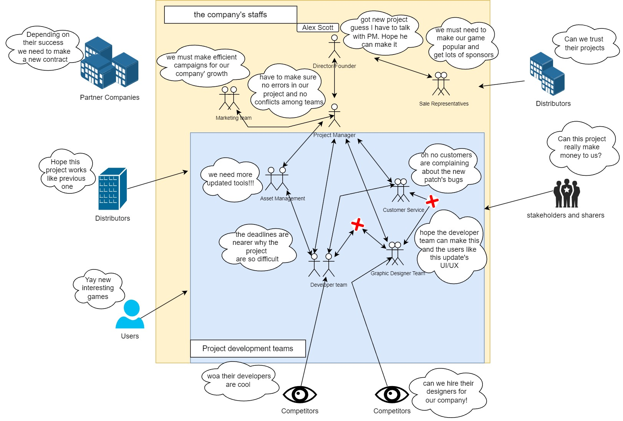

(Kingstone, n.d.)(Anon., n.d.)

**Root Definition**

|  |  |
| --- | --- |
| **Conflicts and Thoughts** | **Solutions** |
| The most seen type of conflict in a developer company is the conflicts between project manager and development team.  -Project manager sometimes gives too much tasks to the team  -Sometime some developers in the team are free with no jobs  -Lacking employees in some projects lead the deadline issues | -To solve these problems, project manager should add new employees to the team. Temporarily hiring developers from the other companies also works.  -If the employees are lazy or their tasks are finished, PM should give more tasks to the team.  -PM should manage time managements carefully to avoid complains from the development team. |
| The problems of development team and designer team usually come next to it.  -The designer team may think about customer’s UI/UX too much and forget about the developers’ side.  -Sometime not adding properties, attributes, reasons lead the developer team take extra unnecessary time. | In this case PM should use soft HRM, and think for the both side and solve the problem without biasing.  -PM should tell the designer team to design simple and codable projects.  -When they design, they should add properties and comments so that developer team can code the process faster. |
| The conflict between customer service and the designer team are usually about that customer’s requirements. Customers are always demanding best graphic and best animations and best sound effects. This led to the small conflicts between the two team.  In this case, developer team also sided together with the designer team. Because some customer’s demands are hard for the company’s employees. | In this case, if some graphic needs to be done fast, PM should hire freelancers for extra demands and let the company’s designer team do the main tasks. |
| Customer service may think all about the players’ reviews all time and fixing the bugs from the updates or from new games. | PM, developer team, designer team and customer service need to talk with each other and brainstorm about the players’ requirements and discuss the capabilities. PM also should explain customer service about which info are needed to announce. |
| Asset management team may not have much big problems till the developer team lost some items during a project. | To solve this problem, they should save more backup data and tools.  And buy things that may be needed in the future.  PM should think about their request too so that company’s budget won’t be waste. |
| Marketing team will need to discuss with project manager about the campaigns and ads ask about the projects’ progresses. It the progresses are near publishing, PM will discuss with the director for the marketing and take approvals from him. |  |
| Sale Representatives will make a bridge between partner companies and the director. This team will show the company’s growth to the partner companies for more monetizing funds. The team will need to discuss with the director for new projects from partner companies and the sponsors. |  |
| Stakeholder and shares will just usually think about the growth about the company all the time. | To let them keep as a share for the company, the company’s growth just have to get higher. And for this to happen, all the employees in the company are working at their best. |
| Competitors have their eyes in the company’s designer team and developer team. Since the employees’ skills are good they are starving to steal the employees from the company. | To avoid that problem, increasing salaries, using incentive system, giving better quality environments, taking care of the employees’ health and their benefits should be added more. |
| For the users, they will be always watching the new games or old game with better updates. |  |

(Anon., n.d.)

**Task 3**

**CATWOE Analysis**

# Task 3 : CATWOE Analysis

|  |  |
| --- | --- |
| Customers | The primary customers are the players in this scenario. Partners and distributors can also be considered as customers. Their reviews and feedbacks are important for facing the company competitions. For them to satisfy, customer service should take data from the users without having bias and report them to the project manager. Project manager will negotiate with the other department leaders and implement the reviews and feedbacks. Project manager will also need to ask the asset management team and negotiate with the developer team about the project’s requirements. After launching the game or game updates, the user’s reviews are needed a lot for the company’s reputations, growths and developments. |
| Actors | Actors are the basically employees in the company. For example, the graphic designers, game developers, graphic artists. They are the company’s talents and they are needed a lot for the company’s future projects. The new skillful actors are necessary and the existed actors are also important to stay in the company. Since the competitors are always looking for the Infinity Games’ talented actors, the comfortability of the existed actors also important like increasing salary, making the workplace lovable and inspirable. So that the ideas, creativities and productivities of the actors will increase. |
| Transformation | The transformations of a company are necessary for the monetization strategies. The outcomes of a projects are not always perfect and the update will be needed always. For a company like Infinity Games, customer experiences, their in-game purchasing, subscription models are main transformations to get monetization. The games debugging and new games creation are also considered as transformations of the company. These transformation for those are done by graphic designers, graphic artists, sound engineers, story writers, game developers and play feedback service teams and with the help of project manager and directors plans, help, tasks and approvals. Without a proper transformation, the monetization strategies will be unsuccessful. And when saying about transformation, it is important for the company to not transform into a company with bad reputations. |
| World view | This can be considered as the most important part in CATWOE. Stakeholders view the company’s business system, the problem that the company facing, the reason of the organization’s existence and what the company should be doing. For example, the stakeholders of the Infinity Games will be looking the company’s new projects, the employees’ skills and the conflicts among the company, the competitors’ eyes and the hardware requirements for the company. They will be looking these and predicts the wider impact of the problems and solutions. |
| Owner | The founder and the stakeholders are the owner of the company. And they have full authority over the company. For example, they can decide whether a project or a system should be implemented. They also have the authority over the employees’ management and can take part in problem solving. |
| Environmental | This element represents the constraints and restrictions that affect the company system and push the projects into limitations. This includes copy rights, laws from different countries, resources, community’s tastes and so on. For example, since the Infinity Games is a game developer company, some limitations like censorship in some countries may be a problematic factor for the games’ popularities and successfulness. In games animations, voice lines, storylines, items-purchasing or character designs can also be a problem in some countries. Currency rates in different countries are also play as a major effect in this case. When choosing an environment, it is important to consider about natural disasters, weather around the chosen environment, market places around it, be sure it is a nice quiet and pleasant place to work, and have to check no rival companies are near around it. If the company is in near rival companies, security role will be important than normal. |

(Cuofano, n.d.) (Anon., n.d.) (Elmansy, n.d.)

**Task 4**

**Process Oriented IS Methodology**

**Process Oriented IS Methodology**

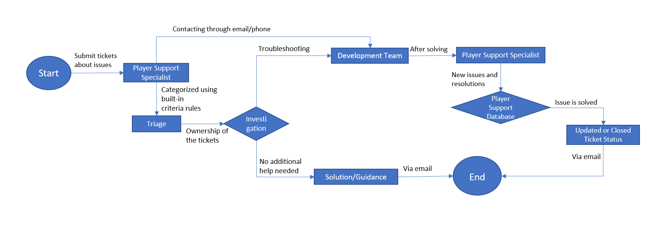

**Evaluation**

For customer service’s manage ticket system, it is a good choice to use process oriented IS methodology than people oriented. There is no creativity or innovations need for manage ticket system and since it is always going with the one flow there no needed of teamworking. Using process oriented IS methodology, there is less error, can reduce employees (because an employee can do many tasks after trained well), system changing is less and will be good for both customers and service specialist. If people oriented is used, there will be bias errors, personal opinions involvements and emotional problems will be big issues not only for players but also for company’s image. This kind of system which is used process oriented can be easy to implement and cost is also predictable. So as a conclusion, Process oriented IS methodology is useful and better for conditions like ticket managing system than using people oriented IS methodology.

**Explain about People oriented IS methodology vs process oriented IS methodology**

|  |  |
| --- | --- |
| **People oriented IS methodology** | **Process oriented IS methodology** |
| -Mainly focus on people’s emotions and problems  -Solving the conflicts by focusing on people’s opinions and no biasing nor punishments  -Good for creativity, innovations and teamwork jobs  -Slower the productivity, less respect on leaders, project managers and directors  -Deadline problems may occur  -Convenient to work, improvement of skills, better network between employees | -Focus on projects’ progresses  -Use hard approach methodology  -Good for productivity and multi-tasking or over loadings  -Not a good choice for creativity and innovative ideas  -No include personal information or emotions  -Deadline issues are not big deal  -Always have to do the same tasks all time |

(Anon., n.d.)

**Task 5**

**PEST Analysis**

PEST Analysis

|  |  |
| --- | --- |
| Political | This focus on the company legislation which may affect the company’s growth in big or small effects. For example, rules, restrictions and policies may improve the productivity of the company but they can also make company innovation or creativities distracted. Costs for taxes will be growth as the company gets bigger which mean this could affect the company budgets a little. Employee’s laws, copyright laws, regional or national laws as well as international laws (like trading items required for game development or game distributions) in different places are also affecting the company’s growth. These laws and policies should be taken carefully and cautiously. |
| Economic | The economic factors can affect the company’s development the most. The exchange rate changes in the different countries can reduce the number of players. The inflations can cause the game’s market’s break downs. And other factors like recessions, challenging with the competitors, supply and demands requirements can also lead to company’s downfall. The company should consider these economic factors in order to avoid making wrong decisions that will reduce the company’s growth potential. |
| Social | This affect the company in more or less way. The company is needed to follow the trends, player’s likes, always listen to the community, targeting the players’ age ranges and always make a favor to them. Social factors can be tricky since there are different types people’s tastes. For example, if the company follow the players’ taste, it would not be innovative and challenging game and as a result it can even become an entertaining company but not a game developer company. But on the other hand, if the company not follow the players’ taste for a little bit, there will be no fan base and the games that produce from the company will be dead games. So, if the competitor companies able to make taste of the customers and players better and can able to make new creations, game logic or algorithms and innovative ideas will make the company’s growth potential gets higher. |
| Technological | Some high technologies are difficult to follow and implement in real life. But the company needed to do everything they can afford. For example, make researches about AR and VR technologies and try to implement and publish it. From the player’s voices, take a list about what to do and show them with higher technologies can improve company’s growth. If the company’s games cannot catch up to the latest and finest technologies and graphics, the image of company will get lower and have to consider that the techniques of the competitors will also be challenging to the company’s growth. |

**Economic factors’ impacts**

The economic factors can affect the company’s growth and cut the potentials of its. Since the Infinity Games is the game developer company, they are withstanding with player’s funding (for example, players buy the product from the games, buy entertaining items related to games, watch videos or buy photobooks of the games and supporting the other games related things). But the exchange rate changes can be both trouble for the players and company. The company demand items’ rates will increase as well as the product aka in-game items prices. If that happens the players will not able to buy the products on the other hand the company is facing with the supplements’ price raised problems. Another big affecting economic factor is inflation. This is bigger problem than the exchange rate problem. Exchange rate differences or rising can be able to solve but inflation problem is affecting not only game industry but also others. It will affect the company’s employees’ salary, utility service prices, tax rates and etc. This inflation problem may not occur yearly or annually and even for some companies, this problem will not occur for them at all. But this type of problem is one of the lists to consider since the company is bigger and bigger. To solve most of the economic problems, having strategic thoughtful business-related employees (eg. Accountants) should be hired and make at least 10 years future plan. And when doing those plans add all those possibilities and always prepare for the worst

(KENTON, n.d.) (MOMIN, n.d.) (Anon., n.d.)

**Task 6**

**User Interface Design**

# Task 6 : User Interface Design

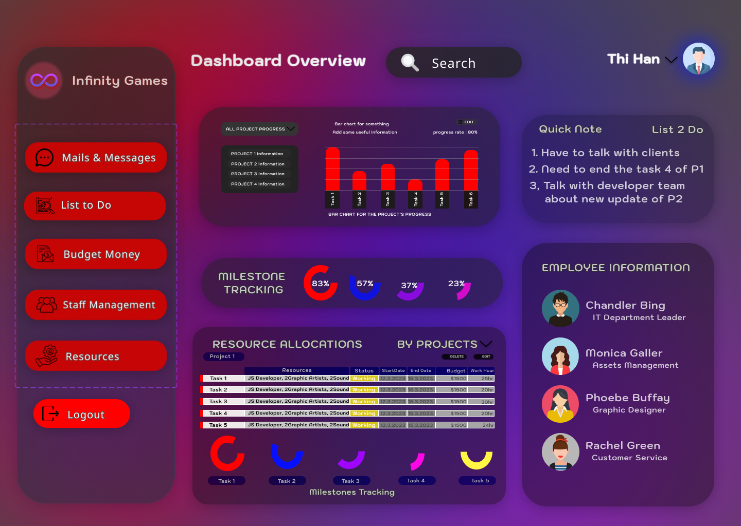

This is the UI/UX design for the project manager’s new off the shelf software’s dashboard. This dashboard page has functions to check mails, list to do, budget money of each projects, staff managements, and resources needed for projects in navigation bar. The project’s details and overviews, milestone tracking for the projects, resource allocations associated with each project. On this page, the employee’s information can also be checked and place them for the jobs that are needing more employees and the employees who are free and needing new jobs. Quick note for the project manager is included in case emergency staffs are needed to be noted or daily works to do can be listed. In case anything is lost or missing, PM can find very quick in the search bar.

(Thefemijohn, n.d.)

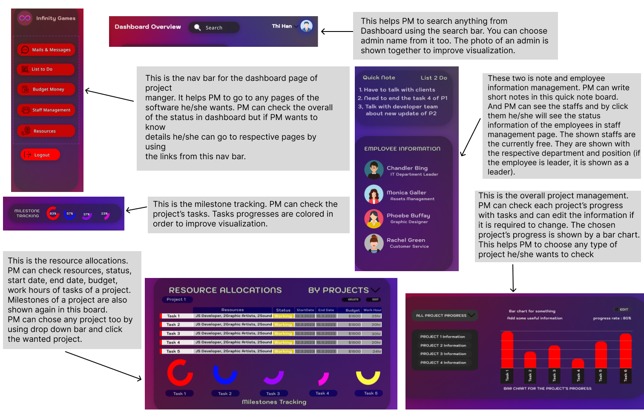

This is the short user manual shown with the picture to improve visualization.

**Task 7**

**Evaluation**

**Evaluation**

|  |  |
| --- | --- |
| **Rich picture** | This tool highlighted the conflicts and connections that are happening inside and outside of the company. By using this tool, the company’s problems can be seen easy to spot, can understand the situation that the people are facing and able to understand and solve the problems and thoughts of employees and the people outside the company. To scope it, it allows broad understanding and visual representation of problems, thoughts and issues, engagement between employees, employers and alignment of the people across the business. |
| **CATWOE** | The effectiveness of this tool are stakeholders’ involvements, improving decision-making, clarity and improve communication, risks identification and solutions are oriented. This tool helps by showing how different elements analyzing the business with their own perspectives. |
| **Business Process Model** | This tool allows clear understanding of the process, consistency and control of the employees, eliminates redundancies and inefficiencies, improved operational performance and can able to standardize. Using this tool in suitable places for example ticket managing system, can be very productive and effective. |

**Additional tools/methodologies**

**System flow chart** : a pictorial or diagrammatic to show the logical operations and information for the organization. This can be used in many ways when processing the systems. This tool helps to know the flow of system so that employees will know when and which process should be done and what projects are in priorities. Using this tool, the company will be systematic, everyone will know their job steps can be able to prepare and knowing the deadlines and tasks preparation managements will be the advantages.

**Decision tree** : to visualize the decision steps and add more decision or negative decision steps to improve the better decisions. This tool can be used by the main decision makers of the company who are the project manager, directors and stakeholders. This tool will make the decision makers to add better decisions, spotting the faulty decisions, brainstorming on the ideas and decisions and removing the useless ideas or negative decisions. Using this tool will help the company stakeholders know the data and knowledge of the project of the company even if they don’t understand some information. Since this tool need the decision makers gather around and make the milestones, they all can able to make better decisions in every different fields (marketing, game development, partnerships, promotions, etc..). This tool can be used for company’s departments or teams. Each team can gather around and make decision trees before starting a project can reduce errors, more info and knowledge and cost. This type of tool is needed for every type of project or system.

**Data gathering** : To collect the analyzed and useful data. This can be done through various sources like documentations, reviews, questionnaires, observation and sampling. This tool can be done by every departments and even for the marketing teams. Using this tool, company’s data gathering time would be shorter and collected data can be re-used in new gaming projects. This tool also allows the company to know the data they having, the usefulness of those data and when making decisions or new projects these data can help in many different ways. This type of tool is needed for game companies since they need a lot of different types of multi-data.

(Anon., n.d.) (Anon., n.d.)

# References

Anon., 2003. [Online]   
Available at: https://www.insurancejournal.com/magazines/mag-mindyourbiz/2003/07/21/31007.htm  
[Accessed 20 December 2022].

Anon., 2010. *MBA offical.* [Online]   
Available at: The screening method does not include any technique to learn about the subject’s past. It’s hard to gather information about early life if you can’t cooperate enough with it. Since there is no other option, scholars should not rely on documents that are a  
[Accessed 16 December 2022].

Anon., 2017. *bayt.* [Online]   
Available at: https://specialties.bayt.com/en/specialties/q/272414/what-the-advantage-and-disadvantage-of-interview/  
[Accessed 16 December 2022].

Anon., 2020. [Online]   
Available at: https://www.mbaofficial.com/mba-courses/research-methodology/features-advantages-and-disadvantages-of-observation/  
[Accessed 13 December 2022].

Anon., 2020. [Online]   
Available at: https://www.yourarticlelibrary.com/social-research/data-collection/questionnaire-method-of-data-collection-advantages-and-disadvantages/64512  
[Accessed 13 December 2022].

Anon., 2020. [Online]   
Available at: https://literacybasics.ca/strategic-planning/strategic-planning-assesssment/overview-and-information-gathering-tools/  
[Accessed 14 December 2022].

Anon., 2020. *ProProfs.* [Online]   
Available at: https://www.proprofssurvey.com/blog/advantages-disadvantages-of-questionnaires/  
[Accessed 16 December 2022].

Anon., 2021. *Marketing Tutor.Net.* [Online]   
Available at: https://www.marketingtutor.net/insurance-industry-swot-analysis/  
[Accessed 20 December 2022].

Anon., 2022. [Online]   
Available at: https://www.actuaries.org.uk/system/files/documents/pdf/0315-0344.pdf  
[Accessed 20 December 2022].

Anon., 2022. *Advantages and Disadvantages of Sampling.* [Online]   
Available at: https://accountlearning.com/advantages-and-disadvantages-of-sampling/  
[Accessed 2 September 2022].

Anon., 2022. *Advantages and Disadvantages of Sampling.* [Online]   
Available at: https://allthingsstatistics.com/miscellaneous/sampling-advantages-disadvantages/  
[Accessed 3 September 2022].

Anon., 2022. *All Things Statistics.* [Online]   
Available at: https://allthingsstatistics.com/miscellaneous/sampling-advantages-disadvantages/  
[Accessed 16 December 2022].

Anon., 2022. *AplusTopper.* [Online]   
Available at: https://www.aplustopper.com/interviews-advantages-and-disadvantages/  
[Accessed 13 December 2022].

Anon., 2022. *AplusTopper.* [Online]   
Available at: https://www.aplustopper.com/advantages-and-disadvantages-of-sampling/  
[Accessed 13 December 2022].

Anon., n.d. [Online]   
Available at: https://intellipaat.com/blog/user-centered-design/  
[Accessed 31 Oct 2023].

Anon., n.d. [Online]   
Available at: https://www.interaction-design.org/literature/topics/user-centered-design

Anon., n.d. *atlassian.* [Online]   
Available at: https://www.atlassian.com/agile/project-management/waterfall-methodology

Anon., n.d. *better evaluation.* [Online]   
Available at: https://www.betterevaluation.org/methods-approaches/methods/rich-pictures

Anon., n.d. *bright.* [Online]   
Available at: https://www.brighthr.com/articles/hris/hard-and-soft-hrm/

Anon., n.d. *Computing Way.* [Online]   
Available at: https://computingway.com/methodology-for-system-analysis/  
[Accessed 19 Oct 2021].

Anon., n.d. *Cyblance.* [Online]   
Available at: https://www.cyblance.com/system-analysis/tools-used-system-analysis-details/

Anon., n.d. *Harvard catalyst.* [Online]   
Available at: https://catalyst.harvard.edu/community-engagement/mmr/

Anon., n.d. *Important Service.* [Online]   
Available at: https://www.improvementservice.org.uk/business-analysis-framework/consider-perspectives/catwoe

Anon., n.d. *Improvising Design.* [Online]   
Available at: https://blog.improv-design.com/soft-systems-methodology/root-definitions/

Anon., n.d. *interaction design foundation.* [Online]   
Available at: https://www.interaction-design.org/literature/topics/user-centered-design

Anon., n.d. *James Cook University.* [Online]   
Available at: https://jcu.pressbooks.pub/pmmethods/chapter/process-based-methodologies/

Anon., n.d. *Personio.* [Online]   
Available at: https://www.personio.com/hr-lexicon/hard-soft-hrm/

Anon., n.d. *projectmanager.* [Online]   
Available at: https://www.projectmanager.com/guides/waterfall-methodology

Anon., n.d. *umsl.* [Online]   
Available at: https://www.umsl.edu/~sauterv/analysis/prototyping/proto.html

Anon., n.d. *visual paradigm.* [Online]   
Available at: https://www.visual-paradigm.com/guide/strategic-analysis/what-is-pest-analysis/

Anon., n.d. *visure.* [Online]   
Available at: https://visuresolutions.com/requirements-management-traceability-guide/agile-requirements-gathering/

Chappal, M. S., 2021. *The 6 key principles of UI design.* [Online]   
Available at: https://maze.co/collections/ux-ui-design/ui-design-principles/  
[Accessed 26 July 2023].

Choudhurs, A., n.d. *Questionnaire Method of Data Collection : Advantages and Disadvantages.* [Online]   
Available at: https://www.yourarticlelibrary.com/social-research/data-collection/questionnaire-method-of-data-collection-advantages-and-disadvantages/64512  
[Accessed 2 September 2022].

Cumbria, U. o., 2016. *Rolfe et al.’s (2001) reflective model.* [Online]   
Available at: https://my.cumbria.ac.uk/media/MyCumbria/Documents/ReflectiveModelRolfe.pdf  
[Accessed 25 July 2023].

Cuofano, G., n.d. *Four Week MBA.* [Online]   
Available at: https://fourweekmba.com/catwoe-analysis/  
[Accessed 13 Dec 2023].

Education, N., n.d. Information System Analysis. In: *People-Oriented IS Methodologies.* s.l.:NCC Education.

Education, N., n.d. Techniques Associated with Requirements Capture. In: *Information System Analysis.* s.l.:NCC Education.

Elmansy, D. R., n.d. *designorate.* [Online]   
Available at: https://www.designorate.com/catwoe-problem-solving/  
[Accessed 12 04 2015].

FutureLearn, n.d. *What, so what, now what?.* [Online]   
Available at: https://www.futurelearn.com/info/courses/career-smart-sell-yourself/0/steps/25057  
[Accessed 25 July 2023].

Hoffman, J., n.d. [Online]   
Available at: https://wisdomplexus.com/blogs/agile-vs-waterfall-pros-and-cons/  
[Accessed 07 May 2021].

indeed, 2023. *How To Become a Claims Representative.* [Online]   
Available at: https://www.indeed.com/career-advice/finding-a-job/how-to-become-claims-representative  
[Accessed 25 July 2023].

KENTON, W., n.d. *investopedia.* [Online]   
Available at: https://www.investopedia.com/terms/p/pest-analysis.asp  
[Accessed 13 June 2023].

Kingstone, I., n.d. *Columbus.* [Online]   
Available at: https://www.columbusglobal.com/en-gb/blog/the-role-of-rich-pictures-in-business-transformation-and-how-to-create-one  
[Accessed 15 Jun 2021].

MOMIN, A., n.d. *PESTLE ANALYSIS.* [Online]   
Available at: https://pestleanalysis.com/video-gaming-industry-analysis/#google_vignette  
[Accessed 27 July 2022].

Paredes, R., n.d. *SafetyCulture.* [Online]   
Available at: https://safetyculture.com/topics/waterfall-methodology/

POLYTECHNIC, O., n.d. *Reflective Writing.* [Online]   
Available at: https://online.op.ac.nz/assets/LearningAdvice/d0a1fac268/Reflective-writing.pdf  
[Accessed 25 July 2023].

Prasanna, 2022. *Advantages and Disadvantages of Observation Method | Merits and Demerits of Observation in Marketing.* [Online]   
Available at: https://www.aplustopper.com/advantages-and-disadvantages-of-observation-method/#Comparison_Table_for_Advantages_and_Disadvantages_of_Observation_Method  
[Accessed 1 September 2022].

Prasanna, 2022. *RS AGGARWAL SOLUTIONS.* [Online]   
Available at: https://www.aplustopper.com/advantages-and-disadvantages-of-questionnaire/  
[Accessed 2 September 2022].

Priya, B., 2021. *What are the principles of user-interface design?.* [Online]   
Available at: https://www.tutorialspoint.com/what-are-the-principles-of-user-interface-design  
[Accessed 26 July 2023].

Rana, K., n.d. *ArtOfTesting.* [Online]   
Available at: https://artoftesting.com/prototype-model#google_vignette  
[Accessed 29 April 2021].

Representatives, I. C., n.d. *Vault.* [Online]   
Available at: https://vault.com/professions/insurance-claims-representatives  
[Accessed 26 July 2023].

Singh, R., n.d. *appvizer.* [Online]   
Available at: https://www.appvizer.com/magazine/operations/project-management/advantages-of-agile-methodology  
[Accessed 14 October 2021].

Thefemijohn, n.d. *Youtube.* [Online]   
Available at: https://www.youtube.com/watch?v=9FPU9gscyGA&t=2257s  
[Accessed 7 Nov 2022].

Tran, T. H., n.d. *invisionapp.* [Online]   
Available at: https://www.invisionapp.com/inside-design/user-centered-design-definition-examples-and-tips/  
[Accessed 24 Jun 2019].

ZipRecruiter, n.d. *Claims Representative Must-Have Resume Skills and Keywords.* [Online]   
Available at: https://www.ziprecruiter.com/career/Claims-Representative/Resume-Keywords-and-Skills  
[Accessed 26 July 2023].

# Candidate Checklist

Please use the following checklist to ensure that your work is ready for submission.



Have you read the NCC Education documents 'What is Academic Misconduct? Guidance for Candidates' and 'Avoiding Plagiarism and Collusion: Guidance for Candidates' and ensured that you have acknowledge all the sources that you have used in your work?

Have you completed the 'Statement and Confirmation of Own Work' form and attached it to your assignment? You must do this.



Have you ensured that your work has not gone over or under the recommended word count by more than 10%?



Have you ensured that your work does not contain viruses and can be run directly?

